**College of Staten Island Computer Science Department**

SOFTWARE REQUIREMENTS SPECIFICATIONS

CSC 430 Prepared By – Abun Eappen,

Kevin Chu, James Loui

Payroll system designed for company Blue ocean

**1. Introduction**

This SRS describes the functional and nonfunctional requirements of the project Blue Ocean. This guide is intended as a roadmap to how the software works and is advised for any employees/admins as a refresher whenever technical issues arise. The SRS follows IEEE std 830-1998.

* 1. **Purpose**

The purpose of Blue Ocean is to automate the payroll processing system for the company for faster, reliable delivery of checks to its employees. The audience will be the employees working in the company and its many other divisions in the tristate. The interface will have easy accessibility in logging in and understanding one’s paycheck information for the company. As for the admins, Blue Ocean will be the number source for updating and storing employee information in the cloud, alongside their accounting book records. This ensures cross-referencing for accuracy in two modes of storage as well as safe backups.

**1.2 Scope**

The purpose of the project, Blue Ocean, is to automate the payroll processing system for the company for faster and reliable delivery of checks to its employees and admins. To do this in a nice orderly fashion, there needs to be methods that will be used to organize and manage records and to make sure all members get their checks. We will have a website that will be used for employees, and admins. Information about the employees and admins will be kept safe in a database server.

Blue Ocean will be helping the employees on viewing their checks, changing their passwords, and calculating past data without ever using a calculator. Admins are who the software is really intended for. Admins will login into Blue Ocean and start the payroll process. This is the main function that will enliven the software, as information for the payroll will be sent to databases thereby adding substance to what is an empty project. Additionally, they can circumvent the payroll process by directly adding, modifying, and deleting employee information, their benefits, tax deductions, net, and gross and promoting/demoting employees.

**1.3 Definitions, acronyms, and abbreviations**

**Hash**- Hashing is a cryptographic method to guarantee safety of information. Blue Ocean will employ the help of PHP function **password_hash(). This function** creates a new password hash using a strong one-way hashing algorithm.[**password_hash()**](https://www.php.net/manual/en/function.password-hash.php)also returns the algorithm, cost and salt as part of the returned hash. This allows the verify function to verify the hash without needing separate storage for the salt or algorithm information. The parameters for the **password_hash()** include the text box password/check number which the user entered as well as the default parameter **PASSWORD_DEFAULT**. This uses the bcrypt algorithm (default as of PHP 5.5.0). Note that this constant is designed to change over time as new and stronger algorithms are added to PHP. For that reason, the length of the result from using this identifier can change over time. To authenticate the user’s logged in password, we use the PHP function [**password_verify()**](https://www.php.net/manual/en/function.password-hash.php)**.**

**Tristate** – Blue Ocean has divisions in the three tristate states. They are New York City, New York; Scranton, Pennsylvania; and Newark, New Jersey.

**Payroll Processing Cycle** – Each check will be inputted in the first and last days of the month. The Pay Frequency will be weekly with 24 checks per year.

**Gross pay** is the amount of money your employees receive before any taxes and deductions are taken out

**Net pay** is the amount of money your employees take home after all deductions have been taken out. This is the money they get on [payday](https://gusto.com/ask-gusto/payroll/what-payday/).

**Permissions** – Each registered user will start off with a null permission value in their database table. This signifies they have no privileges. More privileges can be added to the user after an admin logs in and checks the respective privilege. If all privileges are checked, their permission value will be 63 which signifies admin level.

**Health Insurance** – Blue Ocean will employ the services of Excellus Health Insurance.

**401K** – Blue Ocean will use a any rate constrained to an employee’s total salary. The salary is a fixed amount based on 52 weeks a year multiplied by their rate and their mode of income. This salary will then decide the different rates the employees can choose from rate constrained to a cap of $19,000 per year as per federal guidelines.

**Taxes** – State and local taxes differ based on what division the employee works in. However as per federal guidelines, the federal tax is at 10%, social security is at 6.2%, and Medicare is at 1.45%. In 2019 these are the following rates per division. The New York state income tax is 4% while New York City local income tax is 8%. New Jersey state tax is 5.5% while Newark local tax is 1%. Pennsylvania state tax is 3.07% while Scranton local city income tax is 3.4%.

**1.4 References**

ODELL, HON. MARYELLEN. “TAXES IN NYS.” *NYSACTaxWhitePaper(1).Pdf*, New York State Association of Counties, Apr. 2018, www.nysac.org/files/NYSACTaxWhitePaper(1).pdf.

“Pennsylvania Income Tax Calculator.” *SmartAsset*, smartasset.com/taxes/pennsylvania-tax-calculator.

“New Jersey Paycheck Calculator.” *SmartAsset*, smartasset.com/taxes/new-jersey-paycheck-calculator.

Walczak, Jared. “Local Income Taxes in 2019: Local Income Tax: City & County Level.” *Tax Foundation*, 12 Aug. 2019, taxfoundation.org/local-income-taxes-2019/.

Spector, Joseph. “Health Insurance Rates in New York: Find out How Much They'll Rise in 2020.” *Rochester Democrat and Chronicle*, Albany Bureau, 12 Aug. 2019, [www.democratandchronicle.com/story/news/politics/albany/2019/08/12/health-insurance-rates-new-york-how-much-theyll-rise-2020/1984137001/](http://www.democratandchronicle.com/story/news/politics/albany/2019/08/12/health-insurance-rates-new-york-how-much-theyll-rise-2020/1984137001/).

**1.5 Overview**

The rest of the SRS contains information on how to operate the software. The needed information for both employees and admins are highlighted. There are sections to peruse for needs for clarification or how the software is constrained in certain ways.

**2. Overall Description**

**2.1 - Product Perspective**

This product’s user interface will be in the form of a website for easy accessibility in logging in and understanding one’s paycheck information for the company. Those who are registered to the company can log in the website and use functions provided by the website if they have the privileges that would allow them to use them. Admins are the only members who can register users to the company. Any platforms that can access a website that requires users to login can use this product.

Our product will use a client/server model. The term client/server refers primarily to an architecture or logical division of responsibilities. The client is the application (also known as the front-end), and the server is the DBMS (also known as the back-end).

A client/server system is a distributed system in which,

* Some sites are client sites and others are server sites.
* All the data resides at the server sites.
* All applications execute at the client sites.

**UML Activity Diagram of the Initial steps to Load a Tab**

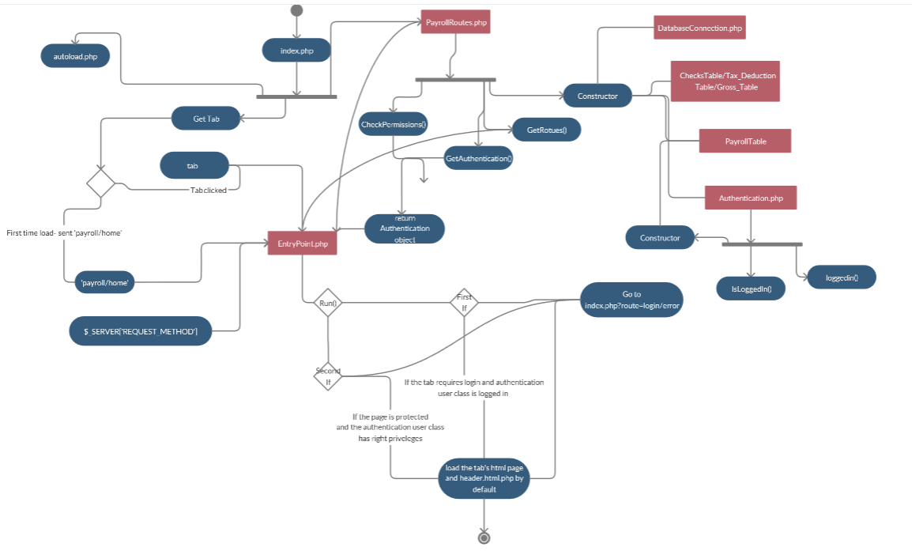

**2.2 - Product Functions**

In this product, there are a variety of functions. It is a website that will allow users to process their checks. The user will automatically be at the homepage with the company’s open message.

**New User Functions**: can use the **register** button to make a new account**, view users** button to see all the users that are already registered, **retiree** button to see all retired employees, **process a dispute check,** and the **company divisions** button to see where our company will mainly be located at.

**Existing User Functions (admin permissions): process a paper check, view all registered users, register new employees, modify/search employees** (each employee will have their tax rates when searching), **tax deductions/gross,** and **payroll processing** (2 checks per month [first day and last day]).

**2.3 - User Characteristics**

The intended user of the product should be the clients. These clients include the employee, employers, and the admins. They are by default part of the company, and only they and not anyone outside the divisions of Blue Ocean can access the website. Their general level of education is advanced, and their technical expertise ranges from functionality with computers and basic software applications like Office to network administrators and HR administrators.

**2.4 - Constraints**

Items that limit the developer’s options vary among many fields. Regulatory policies include the federal guideline for 401K cap to be at $19,000 applies to the software. Anyone who makes more than 19,000 will receive $0 in the gross 401K section in the next paycheck until the end of the year. Hardware limitations include the ability for the user to have a computer on hand. For the employee the use of Blue Ocean is not mandatory since they will receive a physical paycheck anyway.

Deduction based on hours worked include all of health insurance deductions. Health/dental insurance will be only granted to employees who worked consistently for 24 hours for 3 weeks. Other minor constraints include, disputing a unique check and no duplicate disputing checks. If the employees worked more than 8 hours for a regular full-time workday or more than 4 hours for a regular part-time workday, they will receive overtime.

**2.5 - Assumptions and Dependencies**

For admins and HR, the use of Blue Ocean is semi-mandatory. One limitation of a web-based application is the server downtime. Our host 000webhost has been experiencing server downtime many times in the past weeks. Therefore, we are assuming critical information processing could be delayed because the servers are malfunctioning. This is where their secondary backup account, book-keeping, is helpful. Security constraints include the ability for the developer to remember a user’s password. This is impossible since they will only see hashed representation of the fields due to security features. Therefore, they cannot retrieve a forgotten password and the users are warned to remember their passwords.

**3 - Specific Requirements (Section 3 organized by feature)**

**3.1 External interface requirements**

This section provides a detailed description of all inputs into and outputs of the software system.

**3.1.1 User interfaces**

* Front-end software: PHP
* Back-end software: MySQL

**3.1.2 Hardware interfaces**

* Windows
* A browser which supports CGI, HTML, & JavaScript

**3.1.3 Software interfaces**

|  |  |
| --- | --- |
| **Software Used** | **Description** |
| Operating System | We have chosen Windows operating system for its best support and user-friendliness. The website will be cross-browser and mobile. |
| Database | To save employee information, we have chosen MySQL database. |
| PHP | To implement the project, we have chosen PHP language for its more interactive support and server-side scripting. |

**3.1.4 Communications interfaces**

This project supports all types of web browsers. We are using simple PDF check form to print the employee information.

**3.2 System features/Functions**

This section provides a detailed description in fundamental actions that must take place in the Blue Ocean software in accepting and processing the inputs and in processing and generating the outputs.

**3.2.1 System Feature: Register**

**3.2.1.1 Introduction/Purpose of feature**

This feature officially adds a new user to the Blue Ocean database. This way an employee can view their checks and all other functions related to the software.

**3.2.1.2 Stimulus/Response sequence**

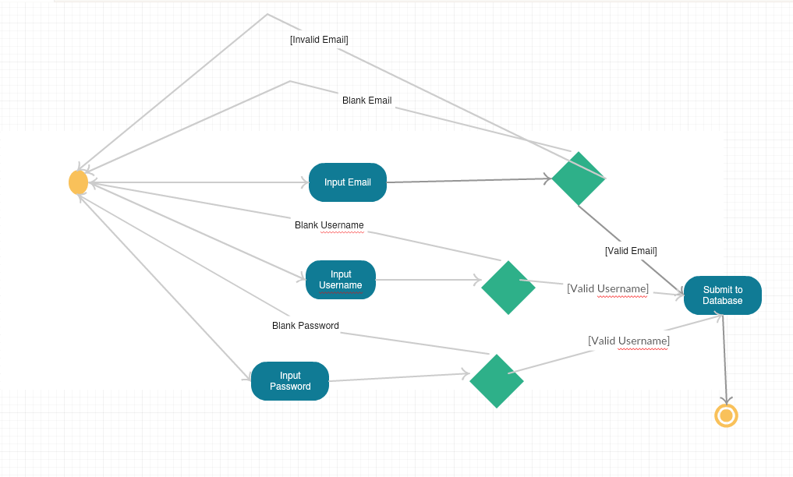

**3.2.1.3 Associated functional requirements**

There will be a Forgot Password button to help any users who want to reset their passwords. Additionally, there will be a submit button that processes the $_POST request.

**3.2.1.3.1 Functional requirement 1**

Design CSS of the page. There will be three text boxes with labels and a Submit button.

**3.2.1.3.2 Functional requirement 2**

Must require the textboxes to be sanitized and free of SQL injections.

**3.2.1.3.3 Functional requirement 3**

Must require the email field to be validated.

**3.2.1.3.4 Functional requirement 4**

Must require the username field to be validated.

**3.2.1.3.5 Functional requirement 5**

Must require the password field to be hashed.

**3.2.1.3.6 Functional requirement 6**

Must re-display the register page with a sticky username field, an empty password field, and a button, Reset Password.

**3.2.1.3.7 Functional requirement 7**

Must re-display the register page with a sticky field if an error occurred such as a blank input.

**3.2.2 System feature: Company Divisions**

**3.2.2.1 Introduction/Purpose of feature**

This feature will mostly be a read-only page that describes the company divisions of Blue Ocean.

**3.2.2.2 Stimulus/Response sequence**

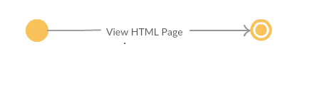

**3.2.2.3 Associated functional requirements**

Read-only HTML page.

**3.2.2.3.1 Functional requirement 1**

Design CSS of the page.

**3.2.3 System feature: New Employee Register**

**3.2.3.1 Introduction/Purpose of feature**

This feature will be used by an admin only and is in the New Employee Functions tab. This will input the important information of a new employee of Blue Ocean.

**3.2.3.2 Brief Stimulus/Response sequence -**

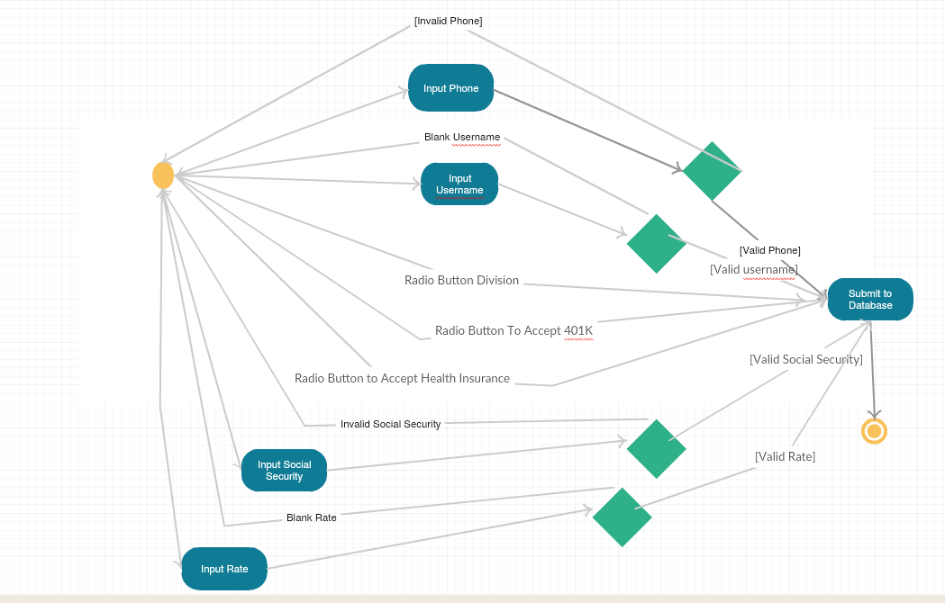

**3.2.3.3 Associated functional requirements**

11 textboxes will be visible along with 3 radio button types. There will be a submit button that processes the $_POST request.

**3.2.3.3.1 Functional requirement 1**

Require invisibility of button upon load of page.

**3.2.3.3.2 Functional requirement 2**

After log-in, require the visibility of button.

**3.2.3.3.3 Functional requirement 3**

Redirect to permissions error page if an employee without full privileges tries to access the button.

**3.2.3.3.4 Functional requirement 4**

Design CSS of the page. Must require the phone/S.S./Direct Deposit-Checking/Routing numbers to be validated and hashed.

**3.2.3.3.5 Functional requirement 5**

Add textboxes for the method of payment. The user can either enroll in checking or direct deposit. If the user enrolled in direct deposit, they must add their routing and account numbers.

**3.2.3.3.6 Functional requirement 6**

Display radio buttons for divisions.

**3.2.3.3.7 Functional requirement 7**

Signify two checkboxes on whether the user is joining as part time or full time.

**3.2.3.3.8 Functional requirement 8**

Add fields like Address, City, State, and Zip Code.

**3.2.3.3.9 Functional requirement 9**

Must re-display the page with a sticky field if an error occurred such as a blank input.

**3.2.3.3.10 Functional requirement 10**

After submit button is clicked, input the textbox fields to the database. Make sure to sanitize the input.

**3.2.4 System feature: Deductions**

**3.2.4.1 Introduction/Purpose of feature**

This feature will be used by an admin only and is in the New Employee Functions tab. This will modify the deductions of each employee.

**3.2.4.2 Stimulus/Response sequence**

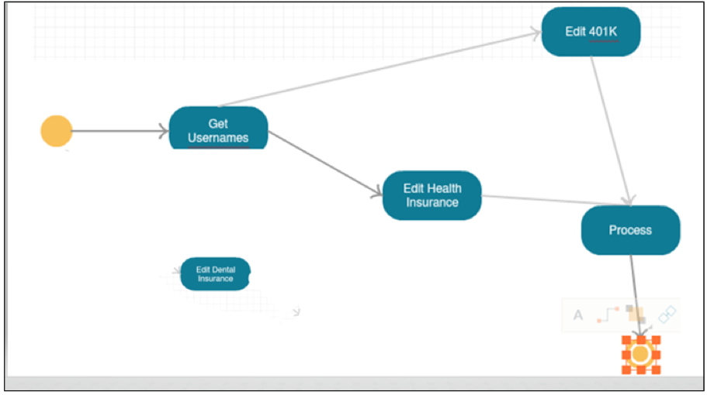

**3.2.4.3 Associated functional requirements**

Design CSS of the page. Each user along with 0 to 3 group related options and a drop-down list will be visible along with a process button.

**3.2.4.3.1 Functional requirement 1**

Require invisibility of button upon load of page.

**3.2.4.3.2 Functional requirement 2**

After log-in, require the visibility of button.

**3.2.4.3.3 Functional requirement 3**

Redirect to permissions error page if an employee without full privileges tries to access the button.

**3.2.4.3.4 Functional requirement 4**

Display a table of employee’s name along with their default health insurance rate and 401K.

**3.2.4.3.5 Functional requirement 5**

When process is clicked, modify the rate in the database**.** Make sure to sanitize the input.

**3.2.5 System feature: Tax**

**3.2.5.1 Introduction/Purpose of feature**

This feature will be used by an admin only and is in the New Employee Functions tab. This will modify the taxes of each employee.

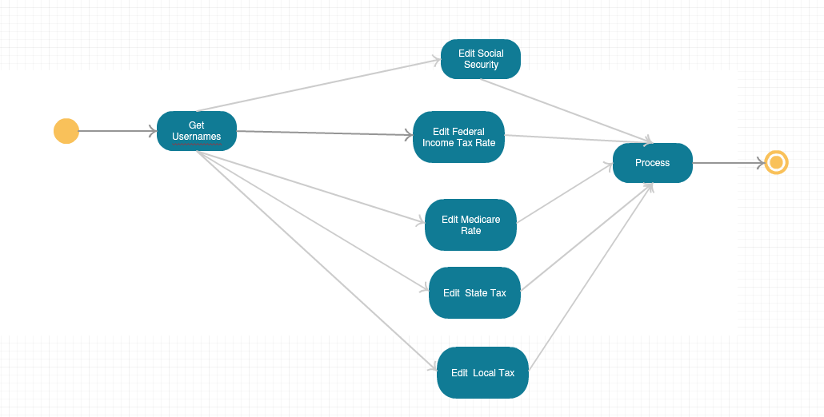**3.2.5.2 Stimulus/Response sequence**

**3.2.5.3 Associated functional requirements**

Design CSS of the page. Each user along with 5 textboxes will be visible along with a process button.

**3.2.5.3.1 Functional requirement 1**

Require invisibility of button upon load of page.

**3.2.5.3.2 Functional requirement 2**

After log-in, require the visibility of button.

**3.2.5.3.3 Functional requirement 3**

Redirect to permissions error page if an employee without full privileges tries to access the button.

**3.2.5.3.4 Functional requirement 4**

Display a table of username along with their default federal income tax rate, social security rate, Medicare rate, state tax rate, city tax rate, and a Process button.

**3.2.5.3.5 Functional requirement 5**

When a Process button is clicked, modify the rates in the database. Make sure to sanitize the input.

**3.2.6 System feature: Gross**

**3.2.6.1 Introduction/Purpose of feature**

This feature will be used by an admin only and is in the New Employee Functions tab. This will display the gross deduction, gross tax, and total income of each employee.

**3.2.6.2 Stimulus/Response sequence**

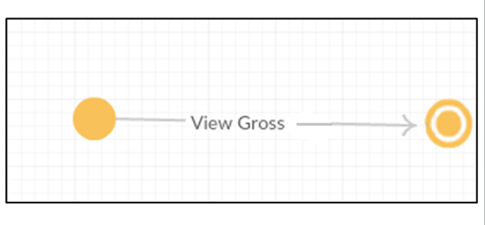

**3.2.6.3 Associated functional requirements**

Design CSS of the page. Each user will be visible.

**3.2.6.3.1 Functional requirement 1**

Require invisibility of button upon load of page.

**3.2.6.3.2 Functional requirement 2**

After log-in, require the visibility of button.

**3.2.6.3.3 Functional requirement 3**

Redirect to permissions error page if an employee without full privileges tries to access the button.

**3.2.6.3.4 Functional requirement 4**

Display a table of user’s name along with their gross tax, gross deduction, and total income.

**3.2.7 System feature: Employee Search**

**3.2.7.1 Introduction/Purpose of feature**

This feature will be used by an admin only and is in the Modify Employees tab. This will display each employee’s information for editing alongside their tax and deduction rates.

**3.2.7.2 Stimulus/Response sequence**

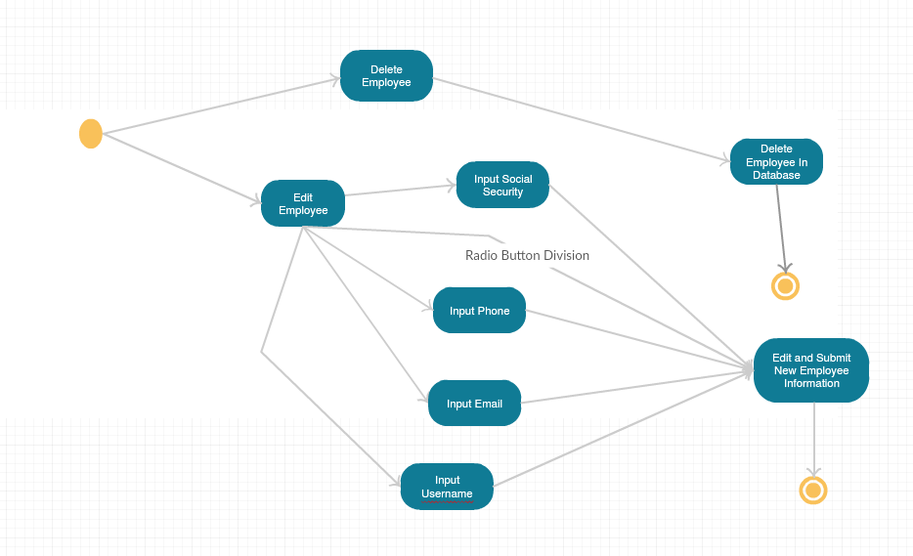

**3.2.7.3 Associated functional requirements**

Each user along with their username, email, phone, rate, salary, address, payment method, note, tax rates, deduction rates, and division will be visible. On the right, there will be a delete button. On the left, there will be an edit button.

**3.2.7.3.1 Functional requirement 1**

Require invisibility of button upon load of page.

**3.2.7.3.2 Functional requirement 2**

After log-in, require the visibility of button.

**3.2.7.3.3 Functional requirement 3**

Redirect to permissions error page if an employee without full privileges tries to access the button.

**3.2.7.3.4 Functional requirement 4**

Design CSS of the page. Once the edit button is clicked the user will be redirected to a new page. Here they can add, modify, delete employee information after clicking the Add Edited Values button.

**3.2.7.3.5 Functional requirement 5**

Once the delete button is clicked, the user will be deleted from the database. That user will be sent to the retiree table for quick retrieval in the future.

**3.2.8 System feature: List of Registered Users**

**3.2.8.1 Introduction/Purpose of feature**

This feature will be used by an admin only and is in the Modify Employees tab. This will display each employee’s username and email. Then, an additional permissions button will be visible to edit their privileges.

**3.2.8.2 Stimulus/Response sequence**

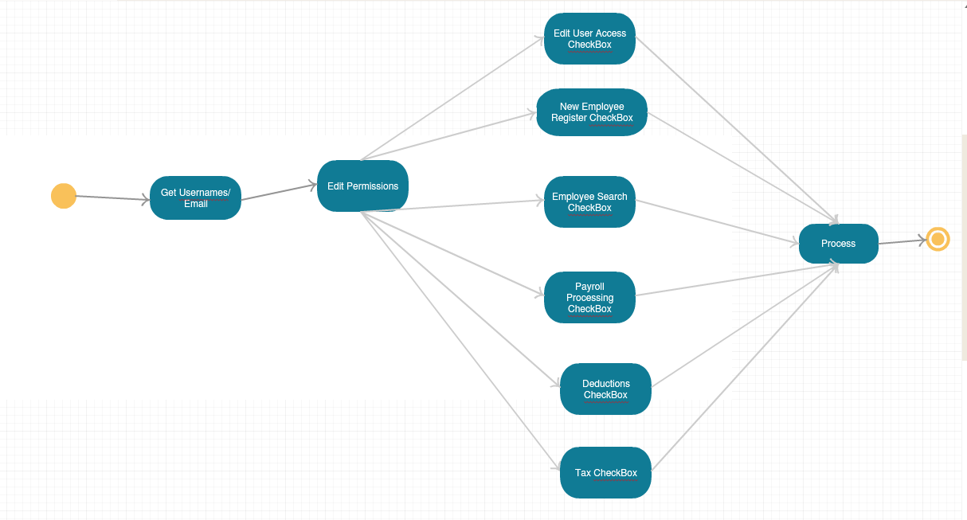

**3.2.8.3 Associated functional requirements**

Design CSS of the page. Each user along with their username, email, and an Edit Permissions button will be visible.

**3.2.8.3.1 Functional requirement 1**

Redirect to permissions error page if an employee without full privileges tries to access the button.

**3.2.8.3.2 Functional requirement 2**

Design CSS of the page. Once the Edit Permissions button is clicked, the user will be redirected to a new page. Here they can add, modify, or delete main employee privileges through checkboxes. Once the submit button is clicked, the privileges will be saved in the database.

**3.2.8.3.3 Functional requirement 3**

If all the checkboxes are checked, elevate the employee to admin.

**3.2.9 System feature: Retiree**

**3.2.9.1 Introduction/Purpose of feature**

This feature will be used by an admin only and is in the Modify Employees tab. This will display each retired or terminated employee’s important information in a table form.

**3.2.9.2 Stimulus/Response sequence**

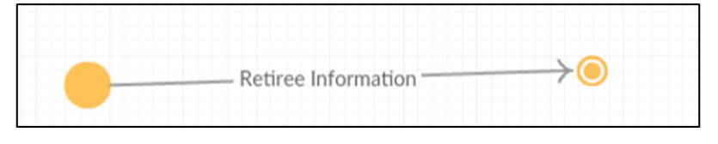

**3.2.9.3 Associated functional requirements**

Design CSS of the page. Each user along with important user, payroll, and deduction information will be visible.

**3.2.10 System feature: Payroll Processing**

**3.2.10.1 Introduction/Purpose of feature**

This feature will be used by an admin only. This will clock in an employee’s total hours they worked for in Blue Ocean.

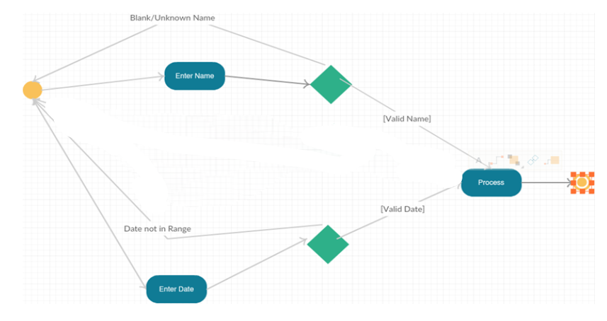**3.2.10.2 Stimulus/Response sequence**

**3.2.10.3 Associated functional requirements**

One textbox will be visible for inputting the username of an employee. A date field will be visible to check on what day they worked.

**3.2.10.3.1 Functional requirement 1**

Require invisibility of button upon load of page.

**3.2.10.3.2 Functional requirement 2**

After log-in, require the visibility of button.

**3.2.10.3.3 Functional requirement 3**

Redirect to permissions error page if an employee without full privileges tries to access the button.

**3.2.10.3.4 Functional requirement 4**

Design CSS of the page. Require one textbox that has label Name. Add a date field starting with year 2019.

**3.2.10.3.5 Functional requirement 5**

Must re-display the page with a sticky field if an error occurred such as a blank input, if an employee is working on a day other than 1st or last days of the month, if the employee is unrecognized, and if the employee is being processed on the same day twice.

**3.2.10.3.6 Functional requirement 6**

After a Process button is clicked, input the textbox fields to the database. Make sure to sanitize the input.

**3.2.11 System feature: Paper Check**

**3.2.11.1 Introduction/Purpose of feature**

This feature will be used by anyone who is logged in and is in the Check Functions tab. They will be able to view their paychecks collected.

**3.2.11.2 Stimulus/Response sequence**

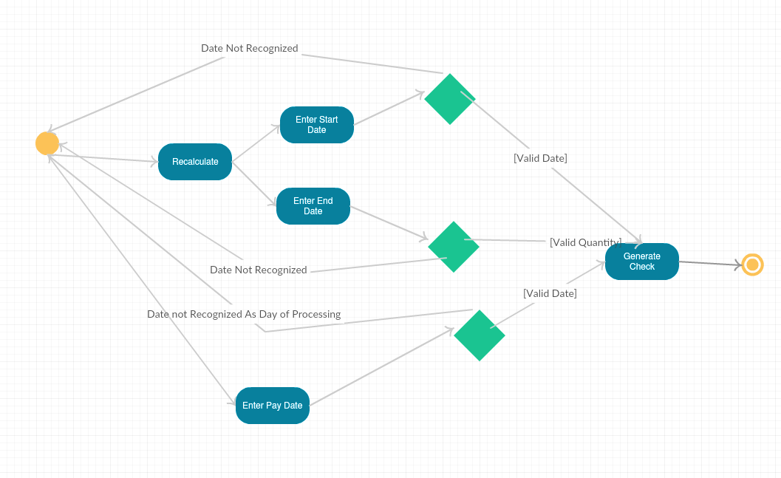

**3.2.11.3 Associated functional requirements**

One date text box will be visible at top alongside a submit button. Once the user enters the right date and clicks the submit button, a paper check will be generated. Additionally, a recalculate button will appear at the top right alongside two date text boxes. The employee can also print a PDF-friendly version of the paper check.

**3.2.11.3.1 Functional requirement 1**

Redirect to permissions error page if an employee without full privileges tries to access the button.

**3.2.11.3.2 Functional requirement 2**

A date text box with a Submit Date for Paycheck Information button will be visible. Once the user clicks the button, generate a page with even columns of all the user’s important information like taxes, deductions, and gross/net pays.

**3.2.11.3.3 Functional requirement 3**

If the user entered an incorrect date, generate an error message.

**3.2.11.3.4 Functional requirement 4**

Two date fields called Begin Date: and End Date: will be visible at the top right. The user will be able to recalculate the amounts with a cumulative view of the paycheck once the Recalculate button is checked.

**3.2.11.3.5 Functional requirement 5**

Throw error if the Begin Date: or End Date fields are incorrect.

**3.2.11.3.6 Functional requirement 6**

Create a PDF-friendly version of the paper check.

**3.2.12 System feature: Dispute Check**

**3.2.12.1 Introduction/Purpose of feature**

This feature will be used by anyone who is logged in and is in the Check Functions tab. They will be able to dispute their paychecks collected, and in the process, an admin can add/subtract net pay.

**3.2.12.2 Stimulus/Response sequence**

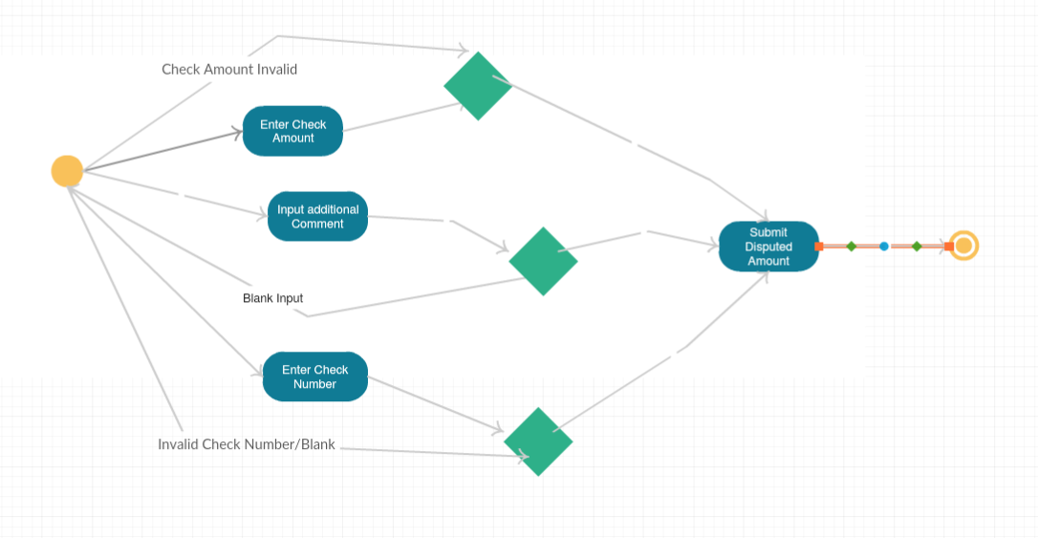

**3.2.12.3 Associated functional requirements**

Three textboxes will be visible. Once the user enters the right paper check number, a request to modify the disputed check’s net pay will be sent to admin notification mailbox. The disputed amount will be reviewed as well as any additional comments from a textbox will be evaluated.

**3.2.12.3.1 Functional requirement 1**

Check if the inputted check number is valid. Check if the check number has already been disputed. If none of these conditions are met, throw an error.

**3.2.12.3.2 Functional requirement 2**

Check if the fields are not blank.

**3.2.12.3.3 Functional requirement 3**

Add notification to admin for disputed amount and check number. Add notification to the notification mailbox of the employee who disputed to notify that the dispute is being processed.

**3.2.13 System feature: Clock In/Out**

**3.2.13.1 Introduction/Purpose of feature**

This feature will be used by anyone who is logged in. They will be able to start their day of work, by clocking in that day, and they can clock out anytime even if the user is logged out. The function will detect if the user worked overtime.

**3.2.13.2 Stimulus/Response sequence**

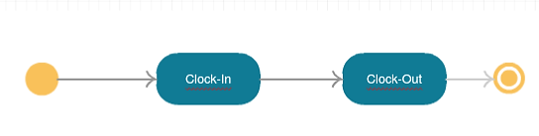

**3.2.13.3 Associated functional requirements**

A very simple Clock In button will be visible to those who just started the work alongside the GMT-5 time right above the button. Once clocked in, the button will change to Clock Out for the user to finish work.

**3.2.13.3.1 Functional requirement 1**

Clock-in user’s time to clock_in_clock_out table.

**3.2.13.3.2 Functional requirement 2**

Clock-out employee’s time to clock_in_clock_out table, creating an interval of work, and generate overtime if the user worked past their income type’s standard times. If the user is full time, overtime is considered past 8 hours. If the user is part time, overtime is considered past 4 hours.

**3.2.14 System feature: Notifications**

**3.2.14.1 Introduction/Purpose of feature**

This feature will be used by anyone who is logged in. They will be able to view their notification mail.

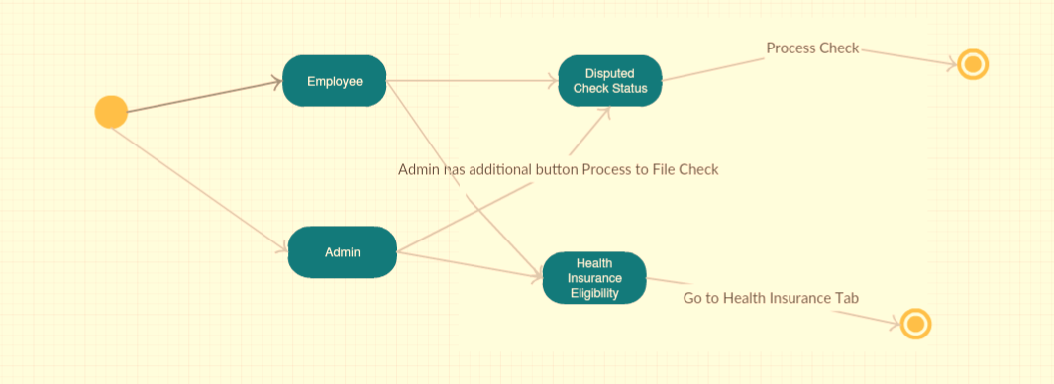**3.2.14.2 Stimulus/Response sequence**

**3.2.14.3 Associated functional requirements**

If the user is an admin, there will be a Process button alongside each disputed check that an employee recently filed. If the user is not an admin, the notification will simply be their status of their disputed check or a special eligibility button for health insurance.

**3.2.14.3.1 Functional requirement 1**

If the user is an employee, show their status of a recently disputed check.

**3.2.14.3.2 Functional requirement 2**

If the user is an admin, show a Process button along each disputed check recently filed.

**3.2.14.3.3 Functional requirement 3**

Process disputed check.

**3.2.14.3.4 Functional requirement 4**

If eligible, show a notification for eligibility for health insurance.

**3.2.15 System feature: Health Insurance**

**3.2.15.1 Introduction/Purpose of feature**

This feature will be used by anyone who is eligible for health insurance. The notification for this eligibility will be found in their notifications tab.

**3.2.15.2 Stimulus/Response sequence**

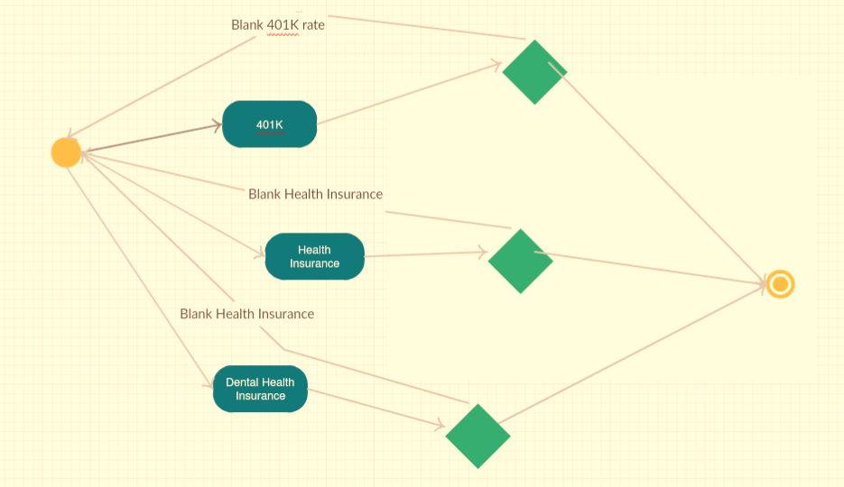

**3.2.15.3 Associated functional requirements**

This tab will make the employee file their health insurance. There will be general health insurance, dental health insurance, and 401K.

**3.2.15.3.1 Functional requirement 1**

Display a salary field of the employee.

**3.2.15.3.2 Functional requirement 2**

With the salary field filled, calculate the variety of 401K percentages that the employee can choose from capping at $19,000.

**3.2.15.3.3 Functional requirement 3**

Create different health insurance metal tier option check boxes, and dental health insurance check boxes.

**3.2.15.3.4 Functional requirement 4**

Once submit button is clicked, modify and add the new health insurance fields to the employee’s payroll table.

**3.3 Performance requirements**

Performance will be limited to our database vendor, 000webhost. As of today, 000webhost supports 10 GB of bandwidth and an almost endless 1 GB disk space. Ideally, 95% of the transactions shall be processed in less than 1s.

**3.4 Logical database requirements**

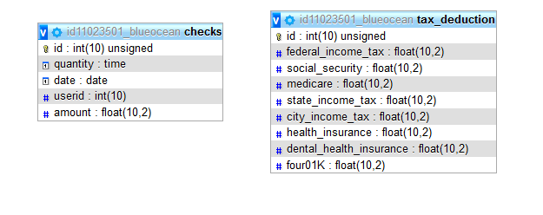

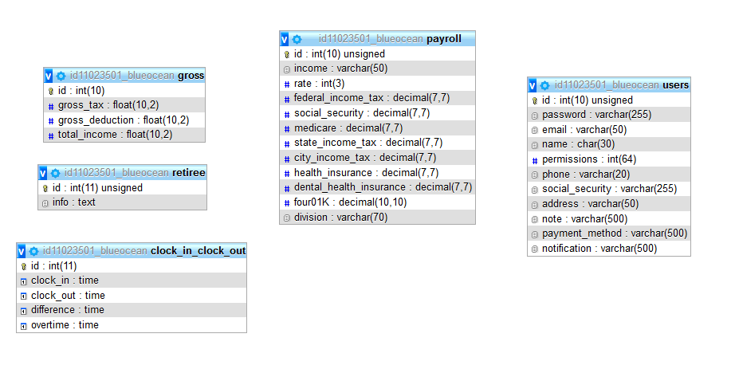

**3.5 Design constraints**

Constraints posed by Blue Ocean on the developer include the schedule of the payroll cycle and tailoring the software around the tristate tax system. For the payroll processing cycle, it was determined that there will be only 2 paychecks per month for a 24-pay periods cycle. The year that Blue Ocean will launch is 2019 January. Therefore, tax and deduction rates will be based on the year of 2019. Health insurance will only be eligible on hours-worked basis. The tax system should be meeting the tristate requirements. Additionally, servers can be limited, so the employers are advised to keep an accounting book as backup.

**3.6 Software system attributes**

**3.6.1 Reliability –**

Factors to promote the reliability of the software include pages responding to viewers with different privileges, the arithmetic is correct in generation of paper checks, employee customer satisfaction is reported to be optimal, etc.

**3.6.2 Availability –**

The website is available every time unless otherwise noted by the webhost, 000webhost. Also, the broadcasting network internet cables, electrical grid, etc. are assumed to be “operational” in the tristate.

**3.6.3 Security –**

Employees and customer service are an asset to Blue Ocean. Therefore, Blue Ocean will take safeguards in protecting vital employee information. We use the latest PHP version 7.2 to avail of the new security features. There are 30 HTML templates and 3 controllers all out of reach from URL hacking. They are securely placed one directory below the public _html folder where only index.php resides. Database connection information is safely stored below the public domain. Only prepared SQL statements will be sent to the databases sanitizing them of any unwanted SQL injections. All textboxes will utilize the safer $_POST request than the $_GET request. Any textbox that is inputted will be sanitized using the PHP function **htmlspecialchars()**. This will convert all HTML to UTF-8. This function prevents HTML injections known as cross-site scripting (XSS). We also use the FILTER_VALIDATE functions to validate the right input values for textboxes as well as checking for blank inputs. Our database tables are normalized to the point of avoiding any ambiguities. The fields value types are carefully designed to consider overflow of information.

The code is carefully designed to avoid repeatability that could lead the way to a vulnerability if the code is altered in the future. Generic classes and the extensive framework are used to be in guidelines with the latest PHP standards (PSR-4). Users who login will have their most valuable information hashed using the PHP security function that uses bcrypt hashing algorithm. Employing the Eksblowfish algorithm that it employs, rainbow table attacks are resisted. To maintain state of a logged in user, we use sessions instead of cookies to avail of server-side processing and its better performance. The session ID will be regenerated each time a user changes the pages to avoid session fixation. A new employee will never have admin privileges the day they register. Instead, admins must grant them permissions. Each admin-access page will be protected each time a user clicks its corresponding link. This way if the user changes their password or by the authentication step above, no two logged in attempts can be created from a single user. Using an Authentication class, the user’s permissions are cross-referenced with the permission required for the page. If the XOR of the permissions are true, they are allowed access, otherwise an error message will occur.

**3.6.4 Maintainability –**

Employers are required to keep an accounting book of all payroll processing starting in 2019. Furthermore, the software is maintainable to an optimal degree due to the use of an extensible framework. There are generic classes that can be resistant to change if a need arises in the future.

**3.6.5 Portability –**

Now the website is recommended to be used in Windows. The website will be cross-browser platform friendly. All browsers will display the information accurately even if the website is in mobile. CSS responsive-design is used for a mobile-friendly website.

**Table of Contents**

1. Introduction

1.1 Purpose

1.2 Scope

1.3 Definitions, acronyms, and abbreviations

1.4 References

1.5 Overview

2. Overall description

2.1 Product perspective

2.2 Product functions

2.3 User characteristics

2.4 Constraints

2.5 Assumptions and dependencies

3. Specific requirements

3.1 - External Interface Requirement

3.2 – System features/Functions

3.3 – Performance Requirements

3.4 - Logical Database Requirements

3.5 – Design Constraints

3.6 – Software System Attributes

4. Table of Contents